

**CONTENTS**

CHAPTER 1 SYSTEM SPECIFICATIONS 1

* 1. DEFAULT VALUES 5
  2. DEVICES 5
  3. OPERATING SYSTEM 6

CHAPTER 2 LOCATION SPECIFICATIONS 5

2.1. LOCATION MANAGEMENT 6

2.2. DATA CENTER MANAGEMENT 7

2.3. COORDINATING MANAGEMENT 8

CHAPTER 3 CABLE SPECIFICATIONS 9

3.1. CABLE CATEGORY MANAGEMENT 10

3.2. CABLE MODEL MANAGEMENT 11

3.3. CABLE MANAGEMENT 12

CHAPTER 4 FABRIC SPECIFICATIONS 13

* 1. SAN GROUP MANAGEMENT 14
  2. SAN MANAGEMENT 15

CHAPTER 5 RACK SPECIFICATIONS 16

* 1. NEW RACK 17
  2. RACK MANAGEMENT 18
  3. RACK DETAILS 19

CHAPTER 6 DASD SPECIFICATIONS 20

* 1. NEW DASD 21
  2. DASD MANAGEMENT 22
  3. DASD CU TYPE MANAGEMENT 23
  4. DASD DETAILS 24

CHAPTER 7 DATA CENTER CONNECTIONS 25

* 1. NEW CONNACTION 26
  2. CONNACTION MANAGEMENT 27
  3. CONNECTION DETAILS 28

CHAPTER 8 BLECH SPECIFICATIONS 29

* 1. NEW BLECH 30
  2. BLECH MANAGEMENT 31
  3. BLECH TYPE MANAGEMENT 32
  4. BLECH DETAILS 33

CHAPTER 9 VT PORT SPECIFICATIONS 34

* 1. NEW VT PORT 35
  2. VT PORT MANAGEMENT 36
  3. VT PORT DETAILS 37

CHAPTER 10 SWITCH SPECIFICATIONS 38

* 1. NEW SWITCH 39
  2. SWITCH MANAGEMENT 40
  3. SWITCH TYPE MANAGEMENT 41
  4. SWITCH DETAILS 42

CHAPTER 11 CONNECTION SPECIFICATIONS 43

* 1. NEW CONNECTION 44
  2. CONNECTION MANAGEMENT 45

CHAPTER 12 USER SPECIFICATIONS 46

* 1. NEW USER 47
  2. USER MANAGEMENT 48

CHAPTER 13 TOOLS SPECIFICATIONS 49

* 1. EXCEL IMPORT 50

CHAPTER 14 REPORTS / FILTER / PRINT / EXPORT 51

* 1. KATEGORIZED REPORTS 52
  2. KATEGORIZED AUTOFILTER 53
  3. PRINT 54
  4. PDF,HTML,MHT,RTF,CSV,TEXT,IMAGE EXPORT 55

CHAPTER 15 KABMAN SERVER TOOLS 56

**INTRODUCTION**

|  |
| --- |
| **CABLING MANAGEMENT SYSTEM** |

The program does consist of two parts :

1. **KabMan Client**

**KabMan Client** enables you to add ,modify and delete the data .It prevents the system from wrong data entries.Furthermore ,it detects empty connections and provides an effective use of these in system again.

1. **KabMan Server Tools**

**KabMan Server Tools** uses SNMP as a protocol ,so it gets the correct results from the hardware and compares these with the current data in **KabMan Client** ,where then these results are updated.

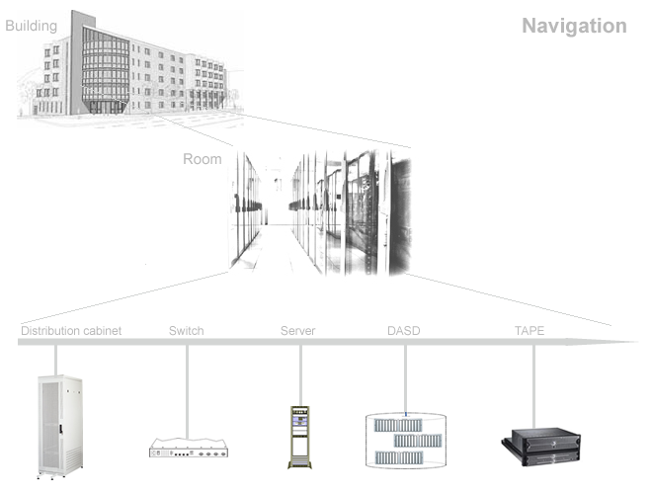



**CHAPTER**

**SYSTEM SPECIFICATIONS**

System adjustments, the origin of **KabMan**, are one of the main modules in this program. Because of its integrity with other modules ,the changes in itself provide a general configuration of whole system ,containing **Rack ,Switch ,Dasd ,Blech ,Vt Port**. It is then possible to make additional changes, ones it is saved .This character of **KabMan** enables him to integrate any other systems.

**Important:** Professional support by a technician on this adjustments and savings is strongly recommended!

**DEFAULT VALUES**

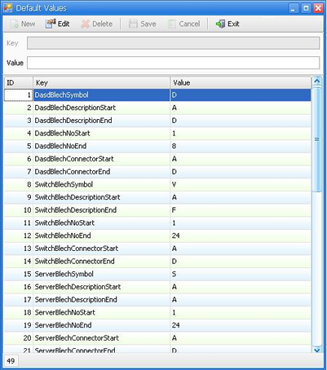

**DEFAULT VALUES**

IT DEFINES THE GENERAL CONFIGURATION REGULATIONS.

YOU CAN GO INTO THE SAMPLES BELOW:

1. SAMPLE

2. SAMPLE

3. SAMPLE

**DEVICES**

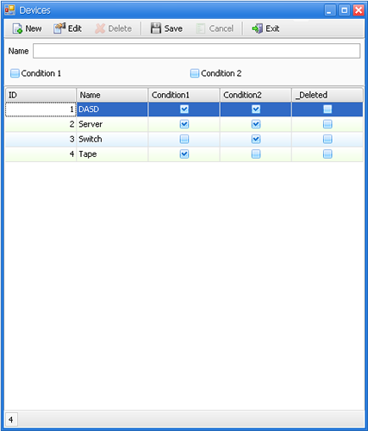

**DEVICES**

SECTION 1: GENERAL HARDWARE DEFINITIONS

SECTION 2: HARDWARE DEFINITIONS FOR BLECH AND VT-PORT

**OPERATING SYSTEMS**

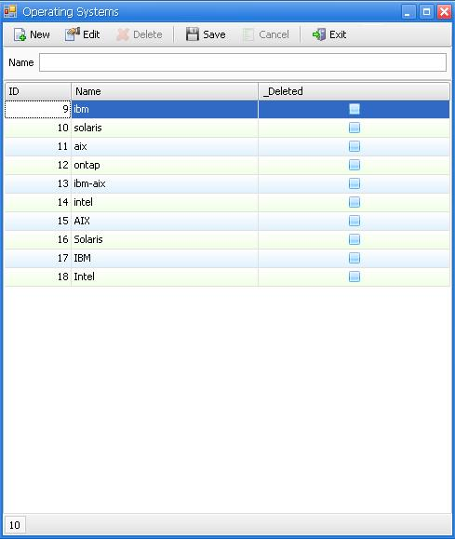

**OPERATING SYSTEMS**

IT DEFINES THE OPERATING SYSTEMS.



**CHAPTER**

**LOCATION SPECIFICATIONS**

This module is based on the tree modelling.

Location: It consists of two main subjects; Data centre and coordinates.

Many other subjects not mentioned above are classified and operated in the same way. It is possible to update all of these subjects. The subjects, which are a part of an upper subject, must be controlled, before this upper subject is deleted.

**LOCATION MANAGEMENT**

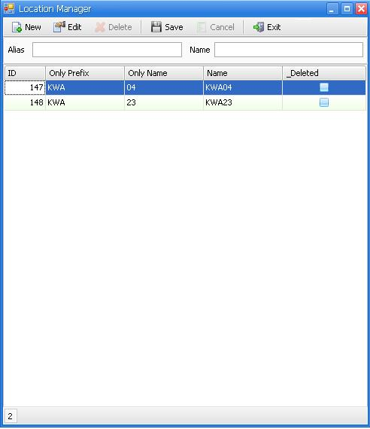

**LOCATION MANAGEMENT**

IT DEFINES THE SETTLED LOCATIONS IN THE SYSTEM.

**DATA CENTER MANAGEMENT**

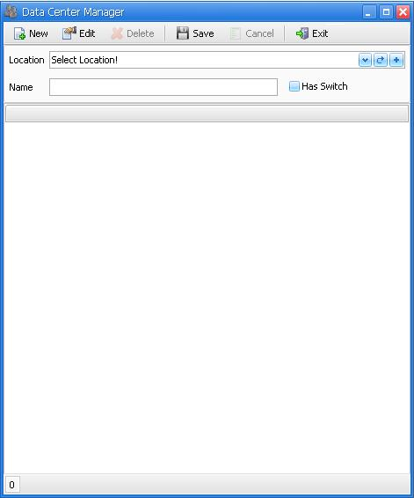

**DATA CENTER MANAGEMENT**

IT IS A DEFINITION SCREEN. CREATES DATA CENTERS UNDER SELECTED LOCATIONS.

**COORDINATING MANAGEMENT**

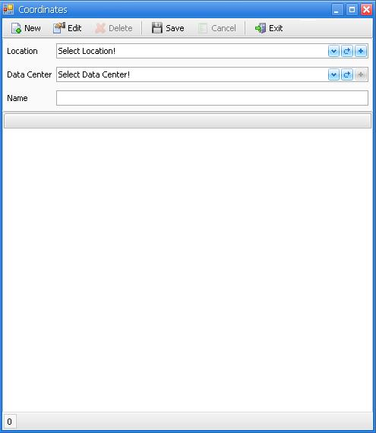

**COORDINATING MANAGEMENT**

IT DEFINES THE COORDINATION, ACCORDING TO THE DATA CENTER VALUES IN THE CHOSEN LOCATION.



**CHAPTER**

**CABLE SPECIFICATIONS**

There are three steps on the cable management algorithm: **Cable Category Management,**

**Cable Model Management, Cable Management**. The integrity in their own makes it very simple to manage all cables entirely. The Cable Categorization prevents every disorder, which might occur during the application. On the other hand, it is thought as an effective method to succeed very fast in a true result.

**CABLE CATEGORY MANAGEMENT**

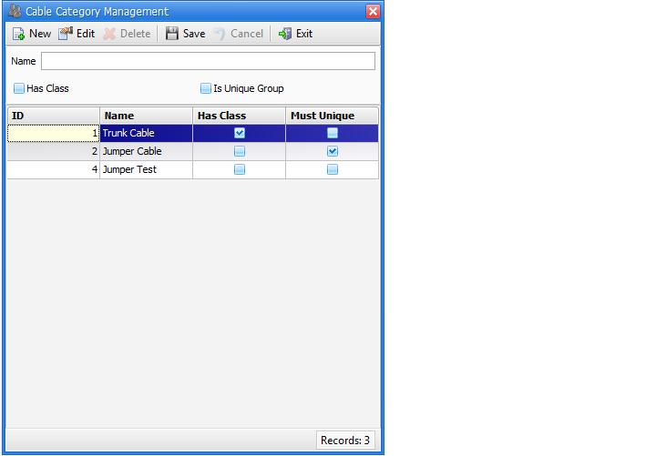

**CABLE MODEL MANAGEMENT**

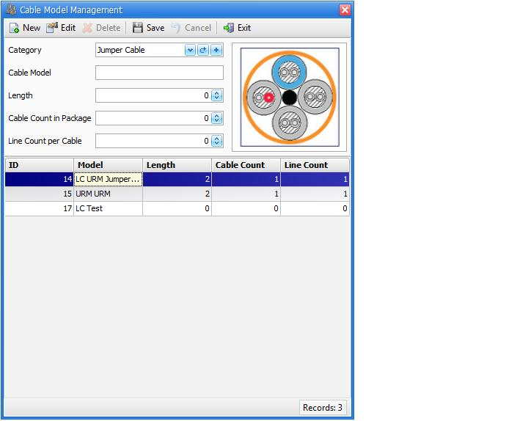

**CABLE MANAGEMENT**

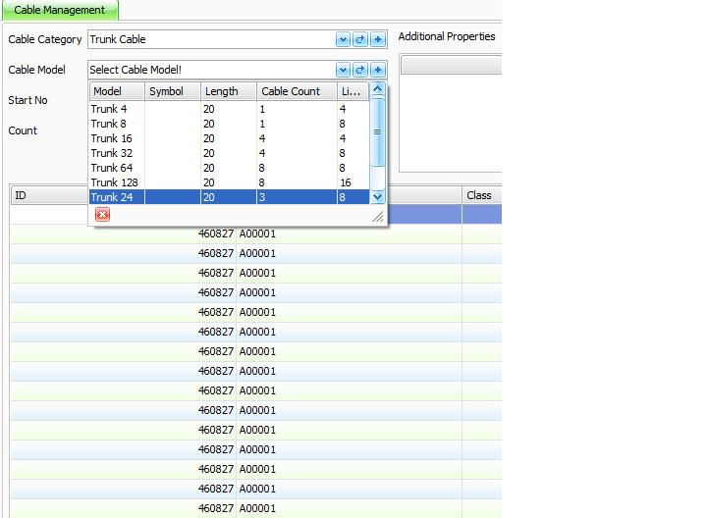

**Cable Category Management:** It forms different cable categorizations,

which might be added to the system later on.

This module contains two groups: HAS Class and IS Unique Group.

1. HAS Class, e.g., A00001.1 trunk cable groups.
2. IS Unique Group, e.g., A00001 URM URM and URM LC

cable groups.

**Cable Model Management:** It forms a model under the formed cable categorization mentioned above.

The functional operation: After the cable categorization is chosen, a model is formed with the value definitions of Count in Package, line count per cable, the model name, and length of this categorization.

Added model names can be updated or deleted.

**Cable Management:** It adds new cables to an appropriate group, according to the chosen category and model.

The functional operation: After the cable category is chosen, it is necessary to choose a model, according to this category. Then a new cable can be added to a group, appropriate to these options. There exists a screen definition of cable specifications.



**CHAPTER**

**FABRIC SPECIFICATIONS**

Because of its expandable nature, SAN is thought as a two-step sub module. The first step is a SAN Group. The second

beneath it is the SAN itself. The functional analysis of these two steps is following below:

* 1. SAN GROUP MANAGEMENT

These created groups are used in many modules on a general system. Therefore it is possible to update their names. Before any deletion, the contents of the modules dependent to these groups must be considered first.

It is sufficient to push the “New” button to give a name to a SAN Group. To delete and update use the “edit” and “slime” buttons on the same screen.

* 1. SAN MANAGEMENT

It forms the SAN´s in the existing group.

It is impossible to create two SAN´s in a group.

Instructional note: After a chosen SAN Group, define a name for it! Define the Blech, Switch and Data Centre Values and save this process!



**CHAPTER**

**RACK SPECIFICATIONS**

**Requirements Checklists**

**INTRODUCTION**

**System Requirements**